
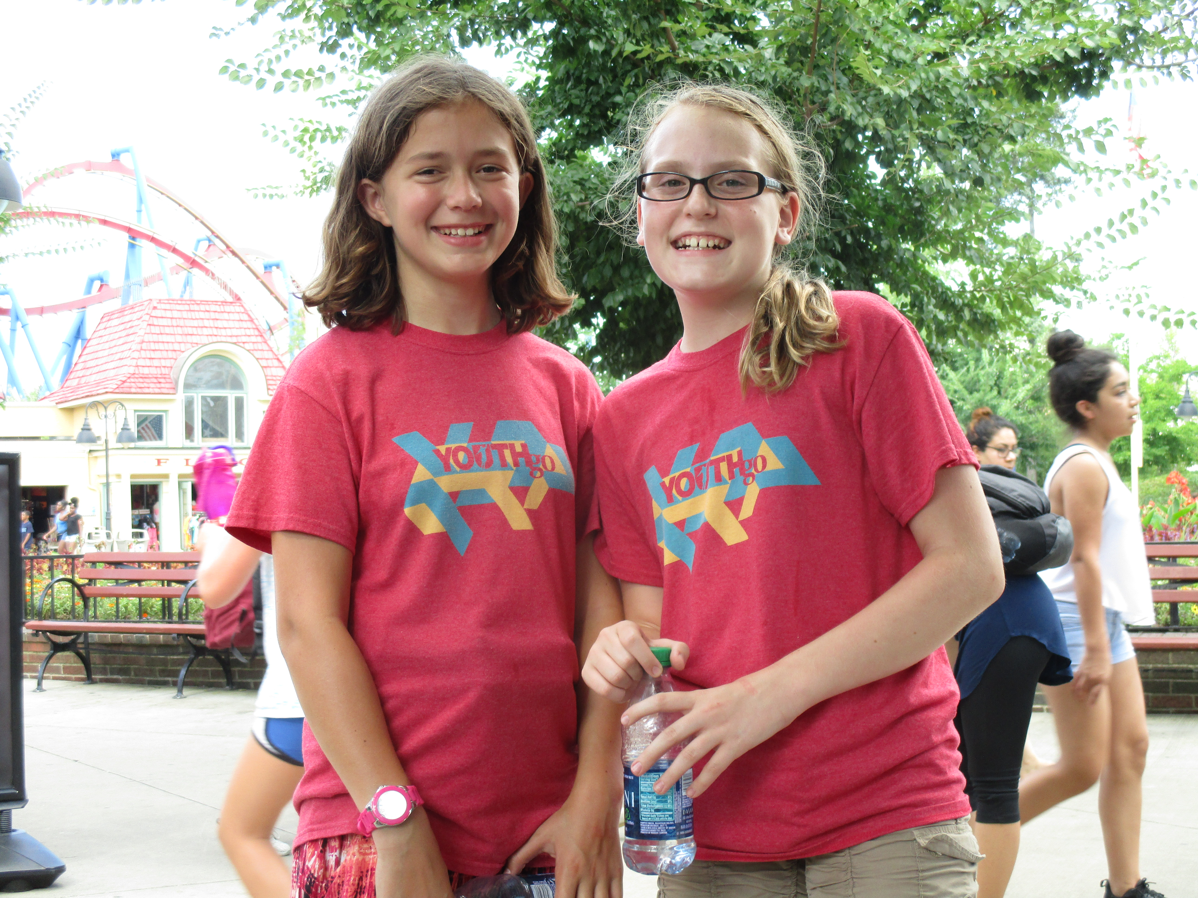
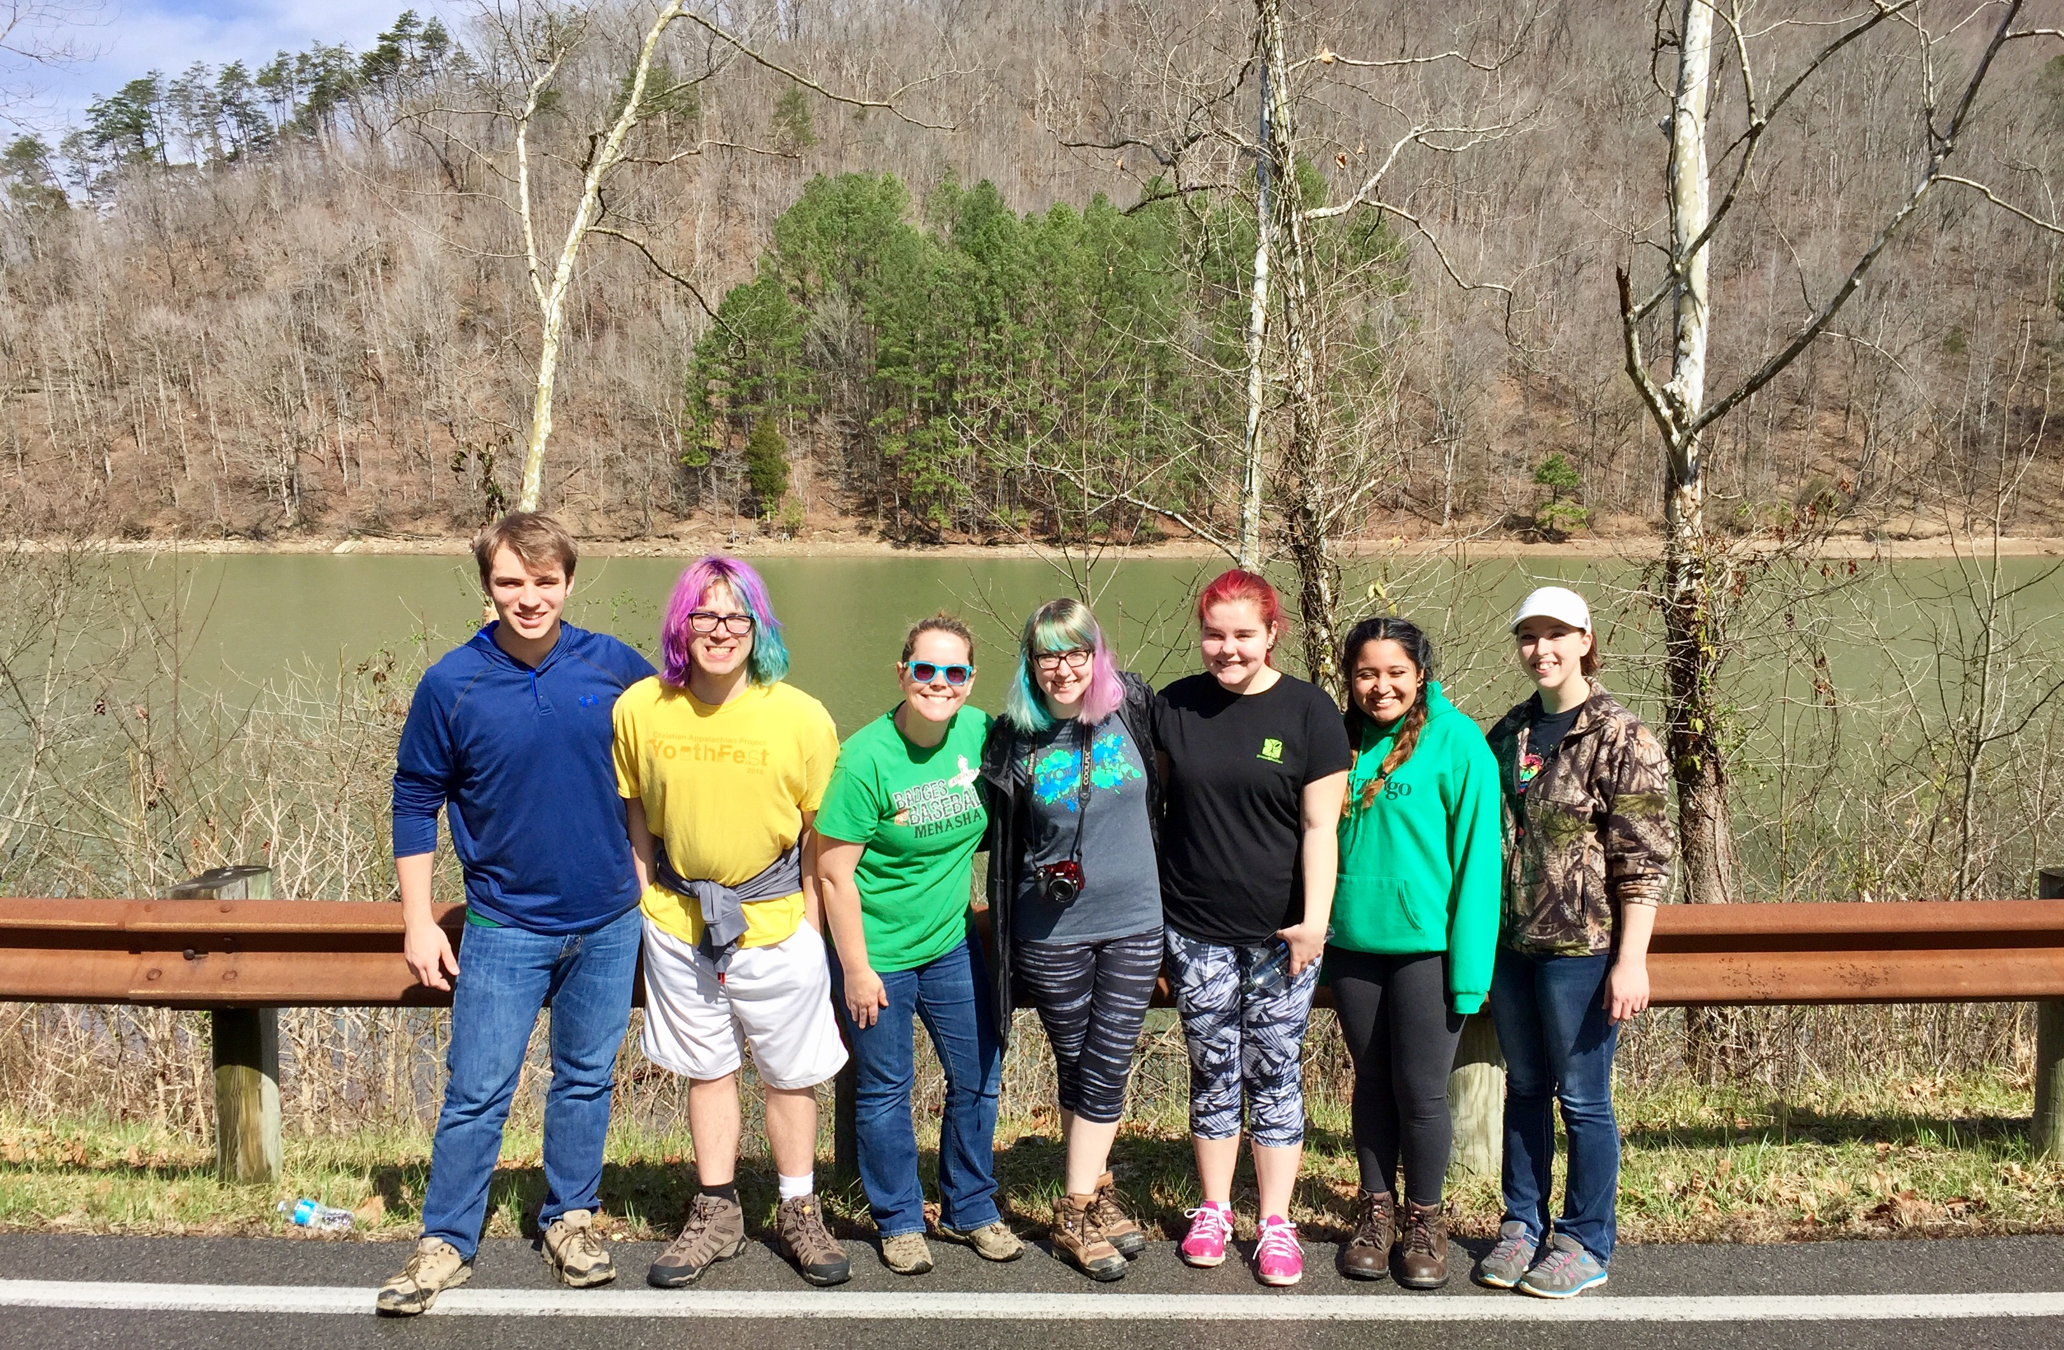


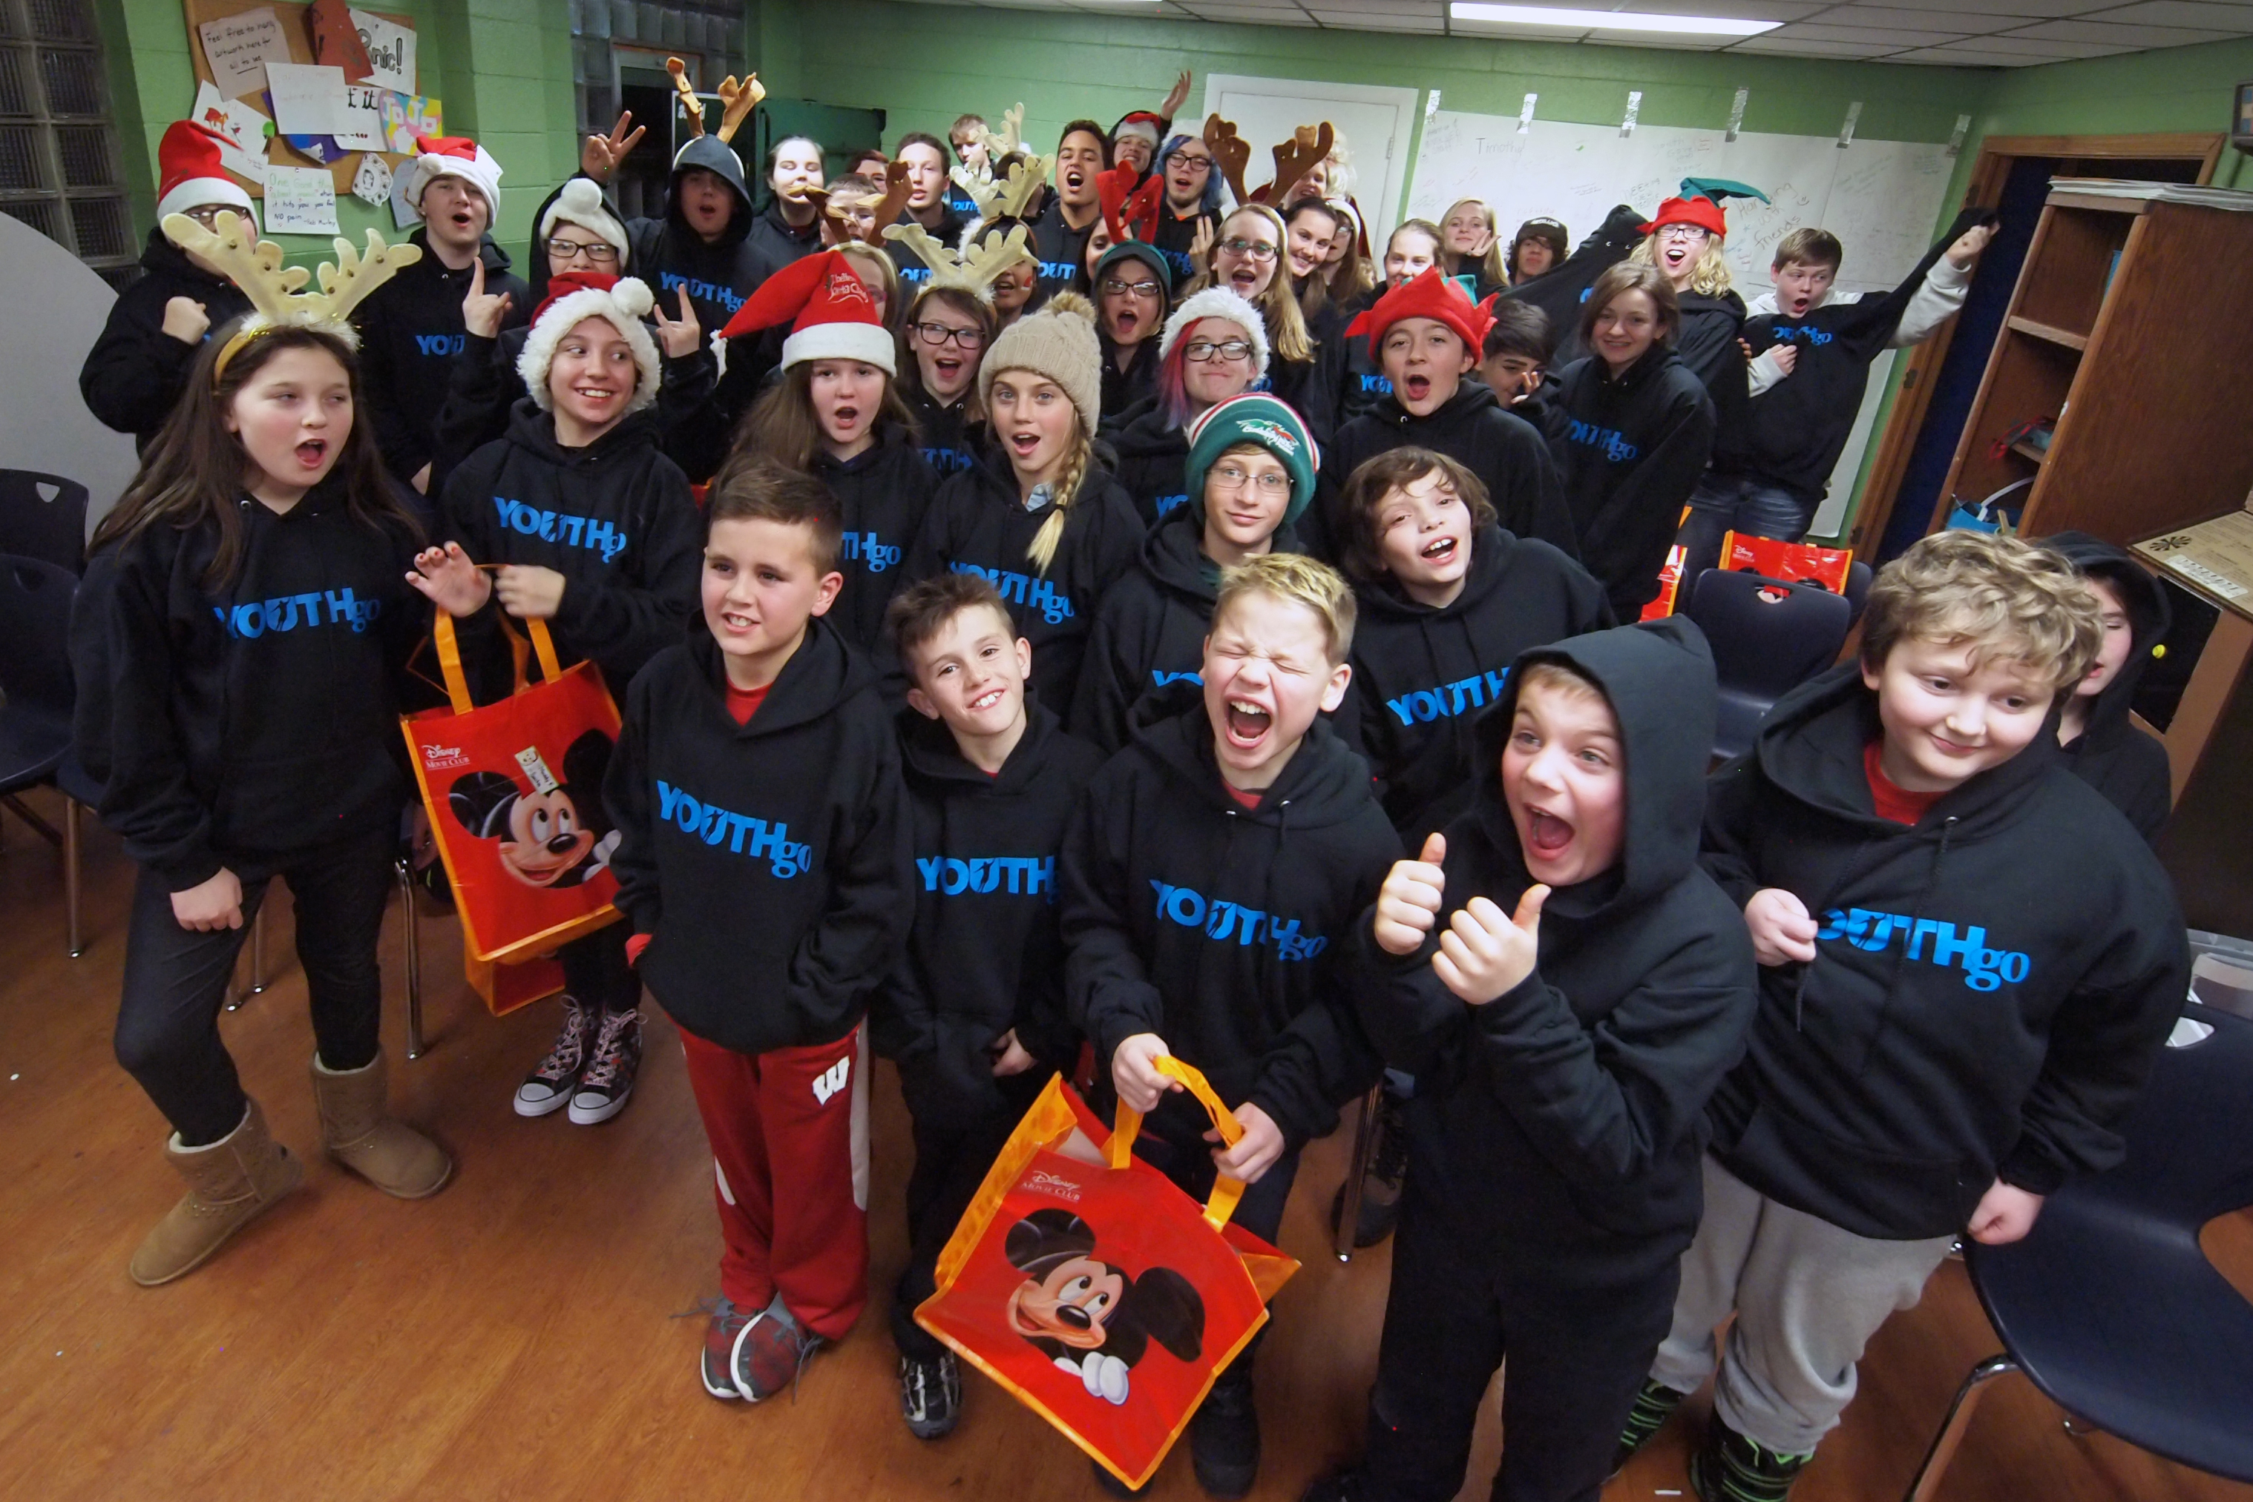
What does offer to Students at NHS?
Transportation
Youth Go offers rides home at 9pm on Monday-Thursday to any youth who lives in the City of Neenah or City of Menasha.
What’s a normal day like at Youth Go?
Monday –Thursday from 6pm-10pm
6:00 Center Opens – youth have access to the entire center including the game room, education room, and computers.
7:00 Dinner and Announcements
7:30-8 Choice to participate in planned activities
8-10 Free Time
Fridays
3:00 Center Opens
3-5 Free Time
5-5:30 Dinner and Announcements
5:30-6:30 Choice of planned activities
6:30-8 Free Time
Recreation Program
*Daily Drop-in Center- a safe and supportive place for all youth.
*Family Nights- four gatherings throughout the year full of fun, friendship, and food.
*Haunted House – volunteer as a scare-actor inside of Youth Go’s Haunted House. All make-up, costumes, and training provided. You just have to show up with a positive attitude. Fridays and Saturdays in October from 5-10pm (permission slip required).
Education Program
*High School Tutoring- transportation provided from the High Schools to Youth Go on Thursdays for homework help. We pick up in front of the school by the rocket.
*Homework Lab- a quiet place offered nightly at the center during our high school hours.
*Monthly speakers on topics such as career exploration, the arts, or interesting hobbies.
*Assistance with job applications, college applications, and help figuring out “what’s next.”
Support and Wellness Program
*One-on-one support from Youth Go staff members whenever you need someone to listen.
*Peer Discussion Groups- groups offered throughout the year.
*Nightly Meals- dinner is offered every Monday-Thursday around 7pm and Fridays at 5pm.
*Monthly speakers on topics such as healthy relationships and making healthy choices.
*Community Service Club- volunteer opportunities available on Thursdays after school.
*SAFE Group Meets on Thursdays at 8pm for youth who identify as LGBTQ+ and straight allies.
When can you come to Youth Go?
High School Program (youth in 7th -12th grade)
Mondays-Thursdays 6:00-10:00pm
Fridays from 3:00-8:oopm
There are no membership fees and everything that takes place at Youth Go is FREE. Youth are not required to come any certain number of days each week and they don’t have to stay the entire time. Youth Go is a drop-in center and our goal is to provide a safe and supportive place for youth to spend their time after school and in the evenings. We also believe it is important to provide quality programming, interesting activities, qualified staff, and a place to have fun!
Youth Go is located at 213 Nicolet Boulevard in Neenah.
For more information call us at (920)722-1435
or visit our website at www.youthgo.org

