
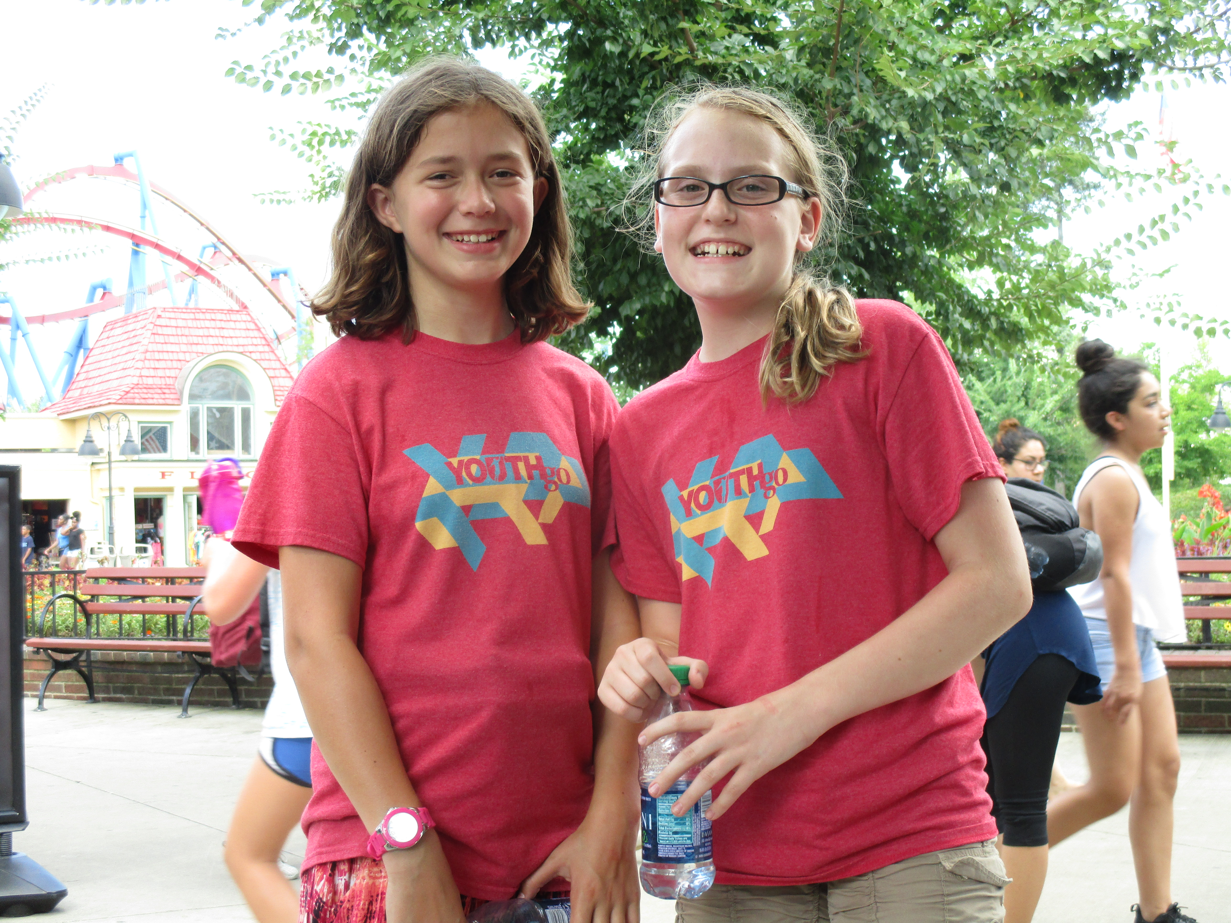
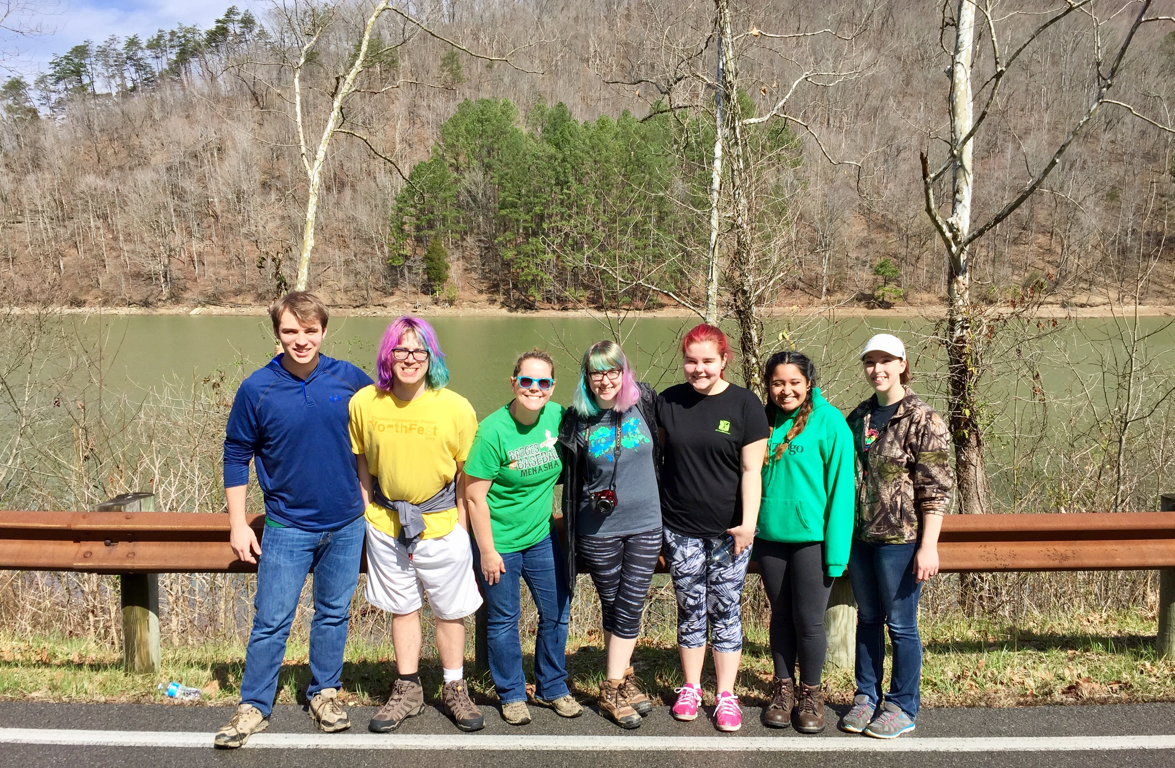


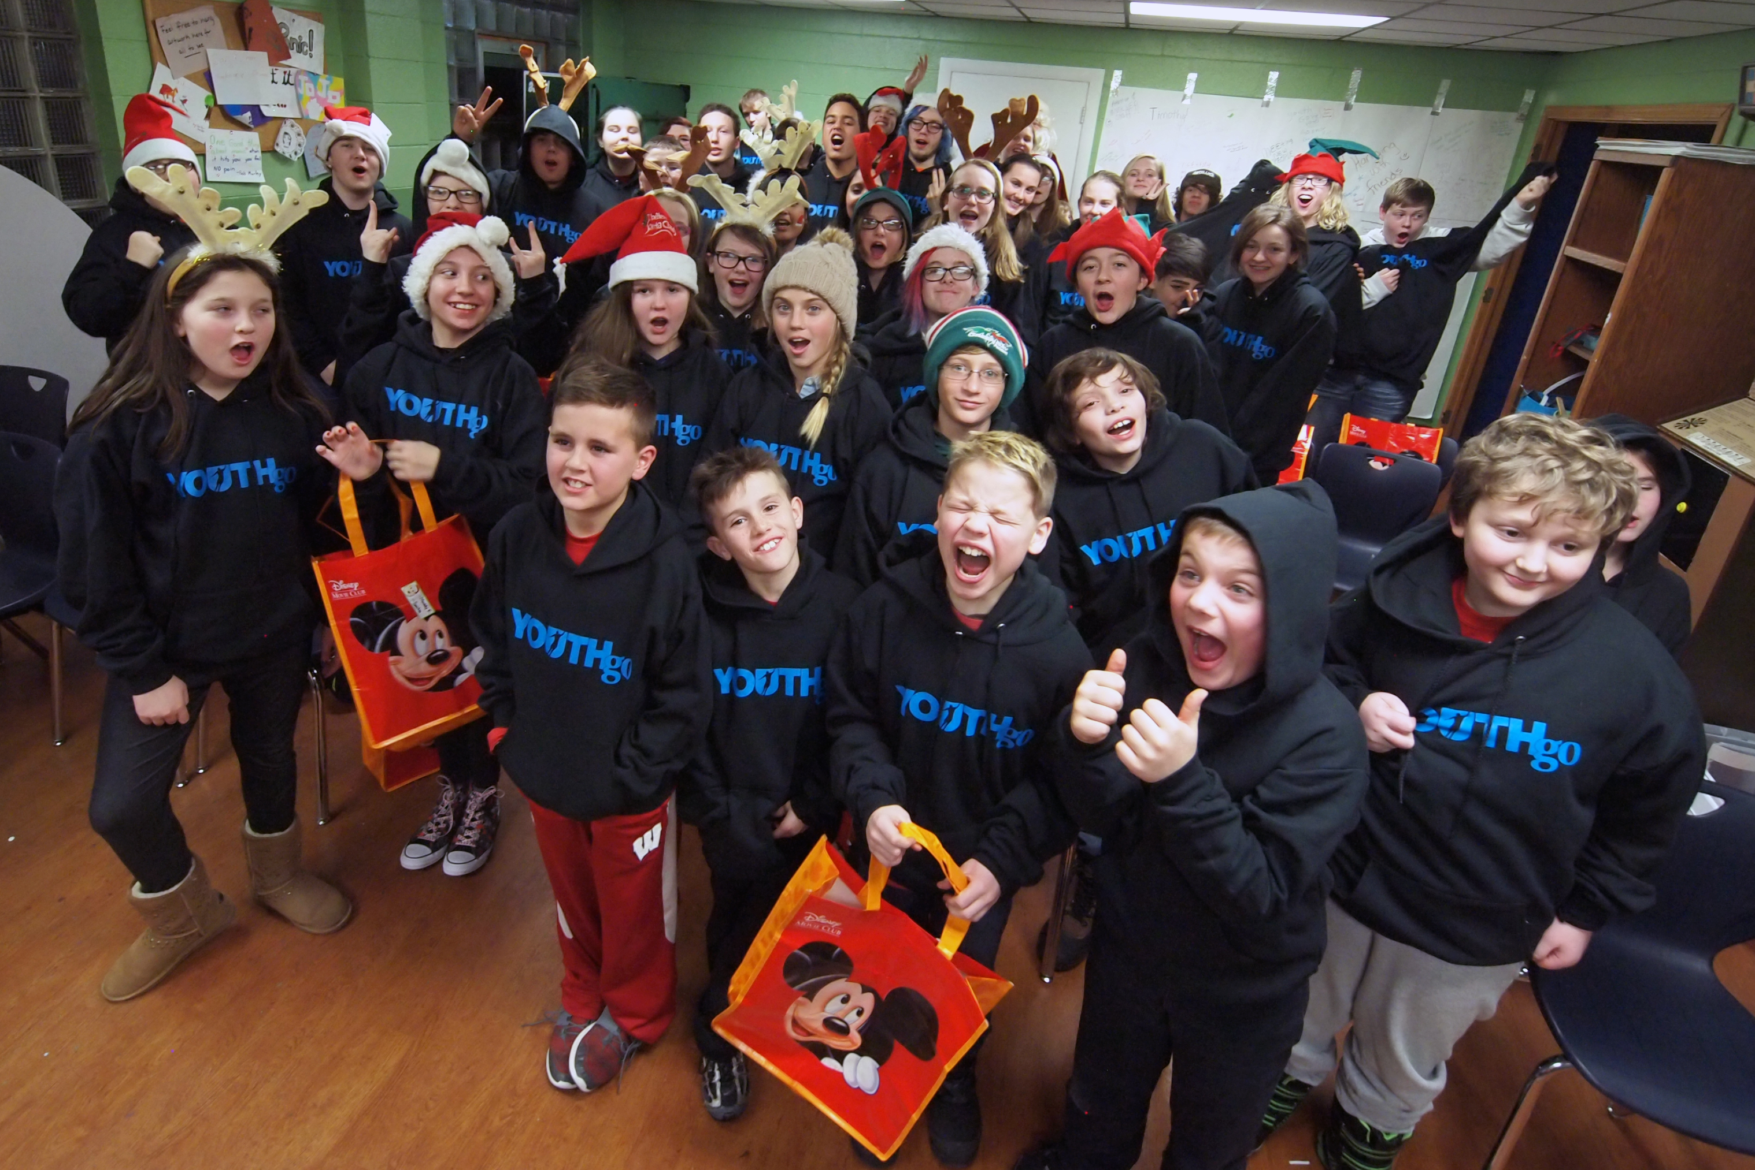
What does offer to Students at Maplewood?
Transportation
During the school year students with a completed transportation permission slip can get a ride from Maplewood to Youth Go after school on Mondays, Tuesdays, Wednesdays and Fridays.
What’s a normal day like at Youth Go?
Monday - Wednesday
2:56-3:10 Ride the vans from Maplewood to Youth Go
3:10-4:10 Snack, Free Time, Homework Time and
Announcements
4:30-5:00 Group Activity
5:00-5:30 Free Time
Fridays
2:56 Ride the vans from Maplewood to Youth Go
3:10-5 Free Time
5-5:30 Dinner and Announcements
5:30-6:30 Choice of planned activities
6:30-8 Free Time
Recreation Program
*Daily Drop-in Center- a safe and supportive place for all youth.
*Family Nights- four gatherings throughout the year full of fun, friendship, and food.
*Haunted House – volunteer as a scare-actor inside of Youth Go’s Haunted House. All make-up, costumes, and training provided. You just have to show up with a positive attitude. Fridays and Saturdays in October from 5-10pm (permission slip required!).
Education Program
*Study Stars- homework time during the first 30 minutes at Youth Go M, T, and W.
*Homework Club- tutoring offered on Thursdays at Shattuck in the Library from 3:15-5:15pm.
*Homework Lab- a quiet place offered nightly at the center during our high school hours.
*Monthly speakers on topics such as career exploration, the arts, or interesting hobbies.
Support and Wellness Program
*One-on-one support from Youth Go staff members whenever you need someone to listen.
* Peer Discussion Groups- groups offered in 3 month sessions throughout the year.
*Nightly Meals- dinner is offered every night around 7pm.
*Monthly speakers on topics such as healthy relationships and making healthy choices.
*Community Service Club- volunteer opportunities available on Thursdays after school.
Transportation is provided and a Permission Slip is required.
When can you come to Youth Go?
Middle School Program (youth in 5th-8th grade)
Mondays, Tuesdays, and Wednesdays from 3:00-5:30pm
Fridays from 3:00-8:00pm
High School Program (youth in 7th -12th grade)
Mondays-Thursdays 6:00-10:00pm
Fridays from 3:00-8:oopm
7th and 8th grade students are invited to attend our Middle School Program or High School Program – some even attend both.
There are no membership fees and everything that takes place at Youth Go is FREE. Youth are not required to come any certain number of days each week and they don’t have to stay the entire time. Youth Go is a drop-in center and our goal is to provide a safe and supportive place for youth to spend their time after school and in the evenings. We also believe it is important to provide quality programming, interesting activities, qualified staff, and a place to have fun!
Youth Go is located at 213 Nicolet Boulevard in Neenah.
For more information call us at (920)722-1435
or visit our website at www.youthgo.org.

